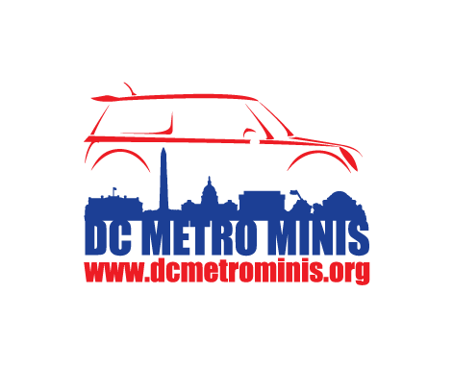  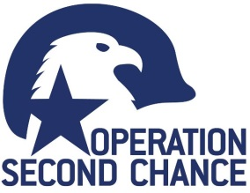 | 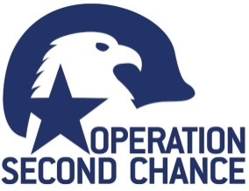
dcmetrominis.org/MTTB  All donations go to: Operation Second Chance  ~ Helping Heroes Move On ~  All donations go to: Operation Second Chance  ~ Helping Heroes Move On ~  All donations go to: Operation Second Chance  ~ Helping Heroes Move On ~  All donations go to: Operation Second Chance  ~ Helping Heroes Move On ~  JOIN your fellow MINIacs for one loop around the beltway!  Hosted by: DC Metro MINIs in support of our Nation’s Veterans.  Sunday, 5 Nov 2017  RSVPs Required! Event details in link below.  All donations go to: Operation Second Chance  ~ Helping Heroes Move On ~  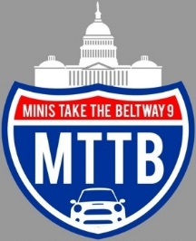 | dcmetrominis.org/MTTB  JOIN your fellow MINIacs for one loop around the beltway!  Hosted by: DC Metro MINIs in support of our Nation’s Veterans.  Sunday, 5 Nov 2017  RSVPs Required! Event details in link below.
dcmetrominis.org/MTTB  All donations go to: Operation Second Chance  ~ Helping Heroes Move On ~  JOIN your fellow MINIacs for one loop around the beltway!  Hosted by: DC Metro MINIs in support of our Nation’s Veterans.  Sunday, 5 Nov 2017  RSVPs Required! Event details in link below. | dcmetrominis.org/MTTB  JOIN your fellow MINIacs for one loop around the beltway!  Hosted by: DC Metro MINIs in support of our Nation’s Veterans.  Sunday, 5 Nov 2017  RSVPs Required! Event details in link below.
dcmetrominis.org/MTTB  All donations go to: Operation Second Chance  ~ Helping Heroes Move On ~  JOIN your fellow MINIacs for one loop around the beltway!  Hosted by: DC Metro MINIs in support of our Nation’s Veterans.  Sunday, 5 Nov 2017  RSVPs Required! Event details in link below. | dcmetrominis.org/MTTB  All donations go to: Operation Second Chance  ~ Helping Heroes Move On ~  JOIN your fellow MINIacs for one loop around the beltway!  Hosted by: DC Metro MINIs in support of our Nation’s Veterans.  Sunday, 5 Nov 2017  RSVPs Required! Event details in link below.
dcmetrominis.org/MTTB  All donations go to: Operation Second Chance  ~ Helping Heroes Move On ~  JOIN your fellow MINIacs for one loop around the beltway!  Hosted by: DC Metro MINIs in support of our Nation’s Veterans.  Sunday, 5 Nov 2017  RSVPs Required! Event details in link below. | 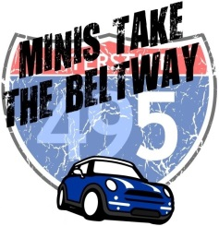  dcmetrominis.org/MTTB  JOIN your fellow MINIacs for one loop around the beltway!  Hosted by: DC Metro MINIs in support of our Nation’s Veterans.  Sunday, 5 Nov 2017  RSVPs Required! Event details in link below.
dcmetrominis.org/MTTB  All donations go to: Operation Second Chance  ~ Helping Heroes Move On ~  JOIN your fellow MINIacs for one loop around the beltway!  Hosted by: DC Metro MINIs in support of our Nation’s Veterans.  Sunday, 5 Nov 2017  RSVPs Required! Event details in link below. | dcmetrominis.org/MTTB  JOIN your fellow MINIacs for one loop around the beltway!  Hosted by: DC Metro MINIs in support of our Nation’s Veterans.  Sunday, 5 Nov 2017  RSVPs Required! Event details in link below.

