NOVA Christmas Lights Mini Run
Total Driving Time – 2 hours 17 minutes

Leg 1 – Drive 1.72 mi, 5 Minutes
Head southwest toward Spriggs Rd
43 ft
Turn left onto Spriggs Rd
0.514 mi
Turn left onto Riverside Dr
0.710 mi
Turn left onto Roundtree Dr
1,306 ft
Take the 3rd right onto Rowser Dr
1,047 ft
Turn right onto Reagon Ct
Destination will be on the left
236 ft
Leg 2 – Drive 3.50 mi, 9 Minutes
Head northeast on Reagon Ct toward Rowser Dr
236 ft
Take the 1st left onto Rowser Dr
0.255 mi
Turn left onto Princedale Dr
0.821 mi
Turn left onto Lindendale Rd
0.301 mi
Take the 3rd right onto Silverdale Dr
0.695 mi
Turn left onto Minnieville Rd
0.808 mi
Turn right onto Cardinal Dr
850 ft
Take the 1st left onto Eastlawn Ave
240 ft
Take the 1st right onto Evansdale Rd
Destination will be on the right

Leg 3 – Drive 4.99 mi, 11 Minutes
Head east on Evansdale Rd toward Edgewater Dr
305 ft
Take the 1st left onto Edgewater Dr
1,224 ft
Turn left onto Eastlawn Ave
0.354 mi
Take the 2nd right onto Cardinal Dr
860 ft
Take the 1st right onto Minnieville Rd
2.86 mi
Turn left onto Smoketown Rd
1.33 mi

Leg 4 – Drive 4.47 mi, 9 Minutes
Head north on Smoketown Rd toward Cavalier Dr
0.752 mi
Turn right onto Old Bridge Rd
2.94 mi
Turn left onto Tanyard Hill Rd
0.362 mi
Continue onto Union St
0.316 mi
Turn right onto Commerce St
Destination will be on the right
522 ft

Leg 5 - Drive 3.07 mi, 6 Minutes
Head southeast on Commerce St
499 ft
Slight left to stay on Commerce St
108 ft
Turn left onto Gordon Blvd
965 ft
Continue onto Ox Rd
1.10 mi
Turn right onto Lorton Rd
Destination will be on the right
1.67 mi

Leg 6 - Drive 10.4 mi, 18 Minutes
Head east on Lorton Rd toward Cardinal Forest Ln
1.46 mi
Turn left onto U.S. 1 N/Richmond Hwy
7.26 mi
Slight right onto Sherwood Hall Ln
0.501 mi
Turn right onto Parkers Ln
0.473 mi
Continue onto Collingwood Rd
Destination will be on the right
0.720 mi

Leg 7 - Drive 14.4 mi, 22 Minutes
Head east on Collingwood Rd toward Glen Cove Court
0.677 mi
Turn right onto George Washington Memorial Pkwy
4.12 mi
Continue onto VA-235
3.04 mi
Turn left onto U.S. 1 S/Richmond Hwy
1.81 mi
Turn right onto VA-286 N/Fairfax County Pkwy
3.88 mi
Take the Barta Road exit toward Virginia 638 S/Rolling Rd
0.334 mi
Turn left onto Barta Rd
0.323 mi
Turn right onto VA-638/Rolling Rd
676 ft
Take the 2nd left onto Richfield Rd
584 ft
Take the 2nd right onto Tangier Dr
Destination will be on the left
102 ft

Leg 8 - Drive 7.30 mi, 11 Minutes
Head southeast on Tangier Dr toward Richfield Rd
102 ft
Take the 1st left onto Richfield Rd
584 ft
Turn right onto VA-638/Rolling Rd
725 ft
Turn left onto Barta Rd
1,220 ft
Take the Virginia 286 N ramp
0.281 mi
Merge onto VA-286 N/Fairfax County Pkwy
1.08 mi
Take the Virginia 286 N/Fairfax Co Pkwy ramp
0.330 mi
Merge onto VA-286 N/Fairfax County Pkwy
3.83 mi
Turn right onto Lee Chapel Rd
1.04 mi
Turn right onto Goldfield Ln
Destination will be on the right
1,224 ft

Leg 9 - Drive 15.4 mi, 28 Minutes
Head northeast on Goldfield Ln toward Lapstrake Ln
1,266 ft
Turn left onto State Rte 643/Lee Chapel Rd
2.10 mi
Turn right onto State Rte 643/VA-123/Ox Rd
1.05 mi
Turn left onto VA-643/Henderson Rd
2.57 mi
Turn left to stay on VA-643/Henderson Rd
2.54 mi
Sharp left onto Old Yates Ford Rd
1.01 mi
Continue onto Yates Ford Rd
2.26 mi
Turn right onto VA-294 W/Prince William Pkwy
1.82 mi
Turn left onto Liberia Ave/Prince William Pkwy
518 ft
Turn right onto Hastings Dr
1.66 mi
Turn left onto Magnolia Grove Dr
Destination will be on the right
486 ft

Leg 10 - Drive 7.55 mi, 18 Minutes
Head northeast on Magnolia Grove Dr towardHastings Dr
486 ft
Take the 1st left onto Hastings Dr
1.28 mi
Continue straight onto Godwin Dr
0.531 mi
Make a U-turn at Business Center Ct
886 ft
Make a U-turn
2.60 mi
Turn left onto Sudley Rd
1.57 mi
Turn right onto Sudley Manor Dr
0.394 mi
Turn left onto Copeland Dr
0.710 mi
Turn left onto Castle Rd
Destination will be on the left
1,086 ft

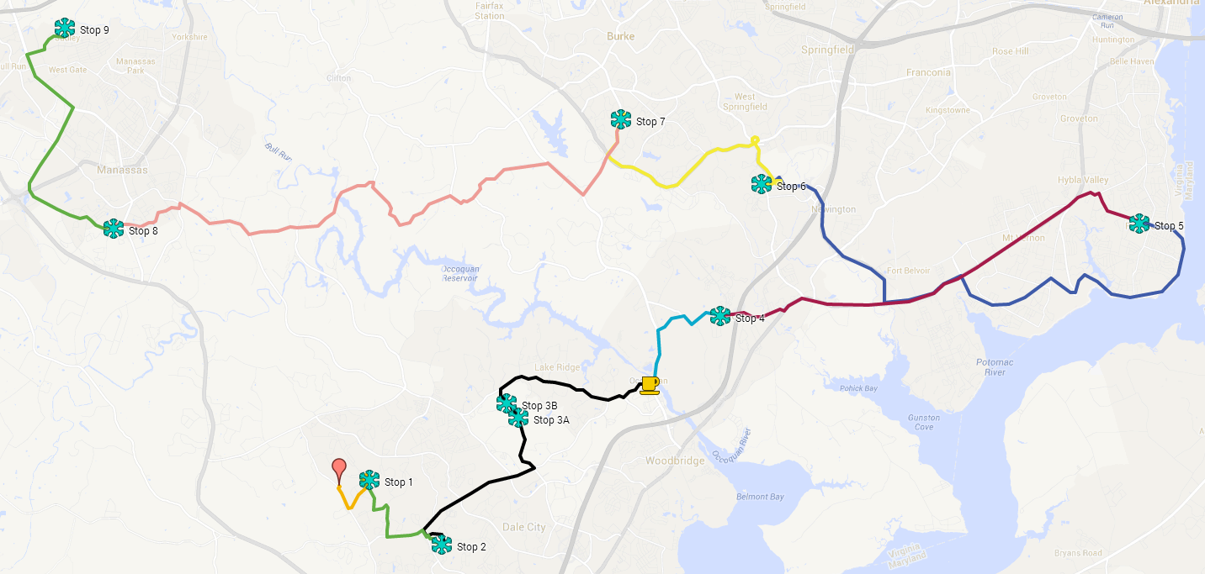

Not the best for smartphones:
https://mapsengine.google.com/map/edit?mid=z2_ArVZtJJ84.kNskWkA1qtzM

